**1.**

there is a **popup panel(sidebar)** in the 3d viewport that you can access by hitting **N** on the keyboard

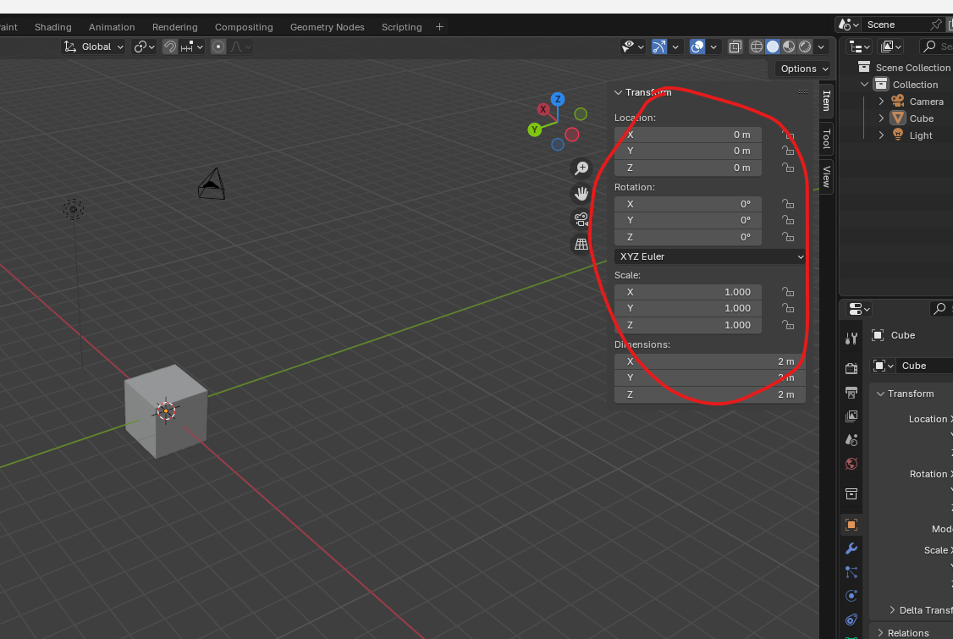  
The popup will be as marked above to pull up the sidebar or panel It can be easily accessed

Again press **N** to close

**2.**

If you press **t** key then it toggle on or off the toolbar on the right side as marked below

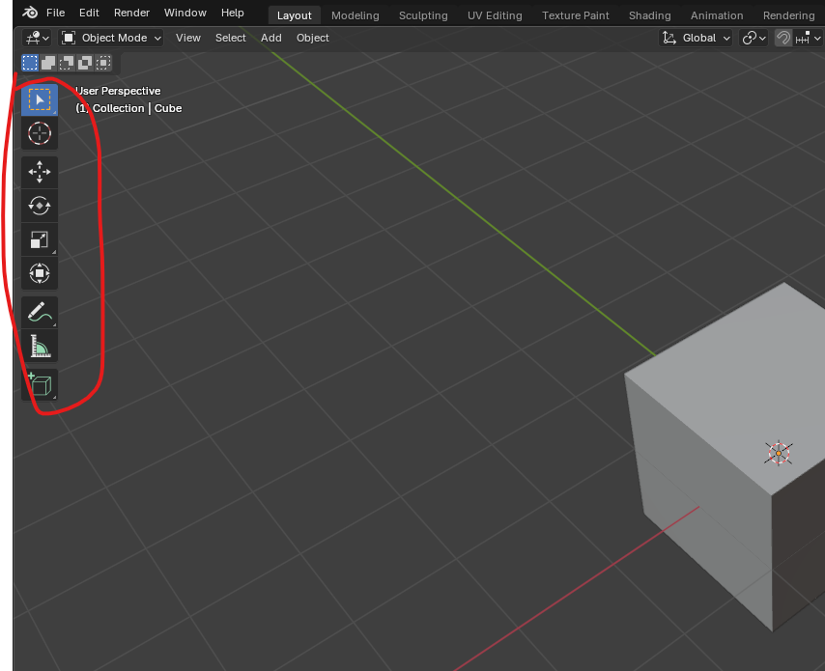

**to rotate your view in blender**

Simply hold the middle mouse wheel and drag your mouse around to rotate around the or any point you treat as your anchor for moving around(maybe).

**To pan your view around without changing the angle at which you(camera) are viewing an object, simply hold shift and middle drag button in the direction you wish to move**

**To zoom just use the scroll bar to zoom in and out**

**If you do not have mouse scroll then hold ctrl and then hold middle mouse button if you move inward then zoom in of the middle mouse go outward then zoom outward**

**But by scroll it zoom grid by grid but in ctrl + middle way it happens smoothly**

**Numpad 5** helps in switching between orthographic view and projection view

to see the front of your model **press 1 on the numpad**

If you want to see from the right side **press numpad 3**

To see form the top press **numpad 7**

in order to view opposite side you just have to hit control and then press the numpad of the side whose opposite you want to view

Now in outlines to rename any file or folder double click on the file or folder or after selecting press **f2**

To hide an object select it and then press **h** button to hide all the object

And press **alt + h** to unhide all the object

Press **Shift + f3** to convert the active panel to the shader editor

Press **Shift + f5** to convert the active panel to the 3d viewport

You can press the **Shift + f3** again and again to toggle between panels whose shortcut key is Shift + f3 you do similarly for the other shortcut key

**Ctrl + S** to save the scene or you can say the 3D model you created in file or maybe the file itself(who knows).

So once it's selected press **G** as in grab. And now you can see that when I move my mouse around, the cube moves with it and pointer shape changes to something which I could not record by snip. Very cool to drop the cube into a new location. Simply left click again when it's in the position that you want it. To drop the selection and cancel the operation while you're moving around. After pressing G **right click** and it will snap back to its original position. This right click way can be used in many circumstance where we want to undo something even in any software other than blender.(who knows)

Now to rotate an object then left click on the object that you want to rotate then hit R as in rotate and move the mouse to manipulate the object as shown below and then

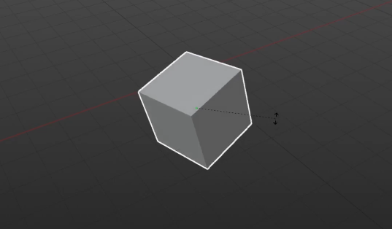

left click again to confirm the rotation of the object to scale an object selected by left clicking hit s as in scale and move the cursor away from the model to scale up as shown below

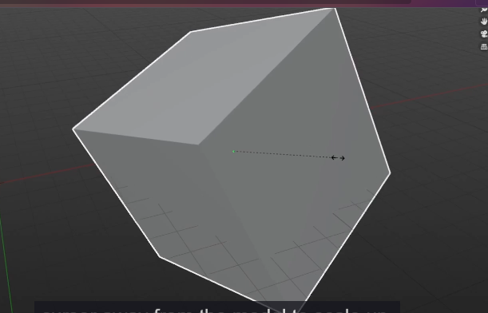

Now move across it towards the object to scale down. As shown below

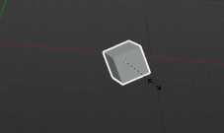

Once again, left click to confirm the new scale.

When you add a new primitive object(they are the object that are by predefined by the blender like cube or sphere )

__________________________________________________________________________________

**Note:-**

To create a primitive mesh object press **Shift + a** on any empty space in 3d viewport

And then a submenu will be opened click on mesh and then in next submenu choose any predefined

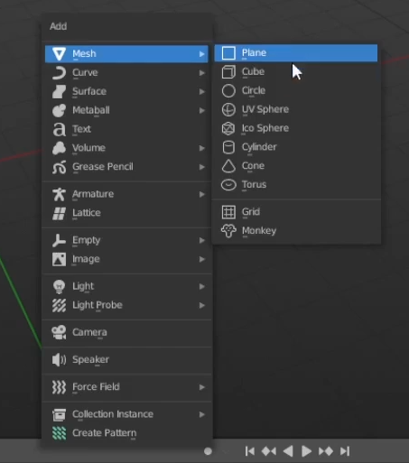

Mesh object you want

**Note:-**

If we press s by left click then it will scale but you can also give it some value while doing so and whatever numerical value you will type that will be that nx of selected object in all axis

For example you press 2 then the result and object will be 2x